***Question No 1:***

* *Reverse a string without using the built-in reverse() method.*

***SYNTAX:***

<!DOCTYPE html>

<html lang="en">

<head>

    <meta charset="UTF-8">

    <meta name="viewport" content="width=device-width, initial-scale=1.0">

    <title>String Reversal</title>

</head>

<body>

    <h1>String Reversal</h1>

    <input type="text" id="inputString" placeholder="Enter a string">

    <button onclick="reverseString()">Reverse String</button>

    <p id="result"></p>

    <script>

*function* reverseString() {

*const* inputStr = *document*.getElementById("inputString").value;

*let* reversedStr = "";

            for (*let* i = inputStr.length - 1; i >= 0; i--) {

                reversedStr += inputStr[i];

            }

*const* resultElement = *document*.getElementById("result");

            resultElement.textContent = `Reversed string: ${reversedStr}`;

        }

    </script>

</body>

</html>

***OUTPUT:***

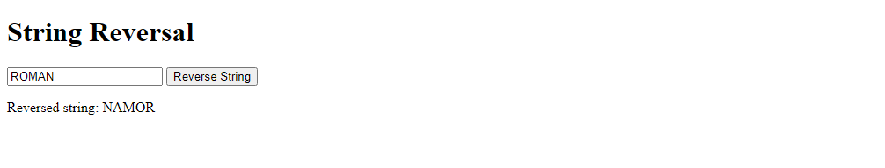

***Question No 2:***

* *Count the number of vowels in a given string.*

***SYNTAX:***

<!DOCTYPE html>

<html lang="en">

<head>

    <meta charset="UTF-8">

    <meta name="viewport" content="width=device-width, initial-scale=1.0">

    <title>Vowel Count</title>

</head>

<body>

    <h1>Vowel Count</h1>

    <input type="text" id="inputString" placeholder="Enter a string">

    <button onclick="countVowels()">Count Vowels</button>

    <p id="result"></p>

    <script>

*function* countVowels() {

*const* inputStr = document.getElementById("inputString").value;

*const* vowels = "aeiouAEIOU";

*let* vowelCount = 0;

            for (*let* i = 0; i < inputStr.length; i++) {

                if (vowels.includes(inputStr[i])) {

                    vowelCount++;

                }

            }

*const* resultElement = document.getElementById("result");

            resultElement.textContent = `Number of vowels: ${vowelCount}`;

        }

    </script>

</body>

</html>

***OUTPUT:***

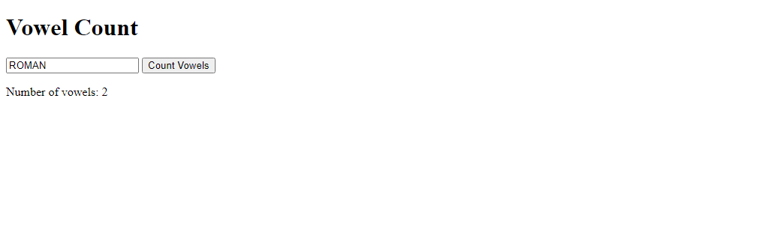

***Question No 3:***

* *Convert the first letter of each word in a sentence to uppercase.*

***SYNTAX:***

<!DOCTYPE html>

<html lang="en">

<head>

    <meta charset="UTF-8">

    <meta name="viewport" content="width=device-width, initial-scale=1.0">

    <title>Capitalized Words</title>

</head>

<body>

    <h1>Capitalized Words</h1>

    <textarea id="inputSentence" placeholder="Enter a sentence"></textarea>

    <button onclick="capitalizeWords()">Capitalize Words</button>

    <p id="result"></p>

    <script>

*function* capitalizeWords() {

*const* inputSentence = document.getElementById("inputSentence").value;

*const* words = inputSentence.split(" ");

*const* capitalizedWords = words.map(*word* *=>* {

                return *word*.charAt(0).toUpperCase() + *word*.slice(1);

            });

*const* resultElement = document.getElementById("result");

            resultElement.textContent = capitalizedWords.join(" ");

        }

    </script>

</body>

</html>

***OUTPUT:***

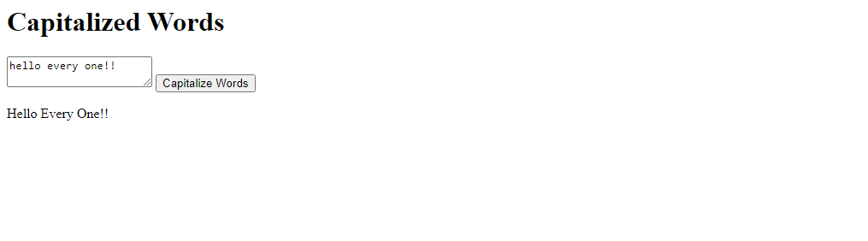

***Question No 4:***

* *Check if a string is a palindrome*

***SYNTAX:***

<!DOCTYPE html>

<html lang="en">

<head>

    <meta charset="UTF-8">

    <meta name="viewport" content="width=device-width, initial-scale=1.0">

    <title>Palindrome Checker</title>

</head>

<body>

    <h1>Palindrome Checker</h1>

    <input type="text" id="inputString" placeholder="Enter a string">

    <button onclick="checkPalindrome()">Check Palindrome</button>

    <p id="result"></p>

    <script>

*function* isPalindrome(*inputStr*) {

*const* cleanedStr = *inputStr*.toLowerCase().replace(/[^a-z0-9]/g, "");

*const* reversedStr = cleanedStr.split("").reverse().join("");

            return cleanedStr === reversedStr;

        }

*function* checkPalindrome() {

*const* inputStr = document.getElementById("inputString").value;

*const* isPalindromic = isPalindrome(inputStr);

*const* resultElement = document.getElementById("result");

            if (isPalindromic) {

                resultElement.textContent = "The string is a palindrome.";

            } else {

                resultElement.textContent = "The string is not a palindrome.";

            }

        }

    </script>

</body>

</html>

***OUTPUT:***

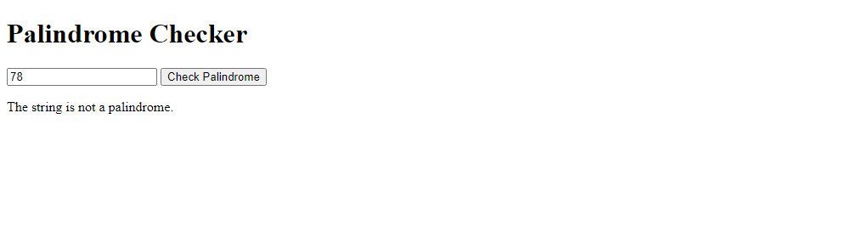

***RESULT:***

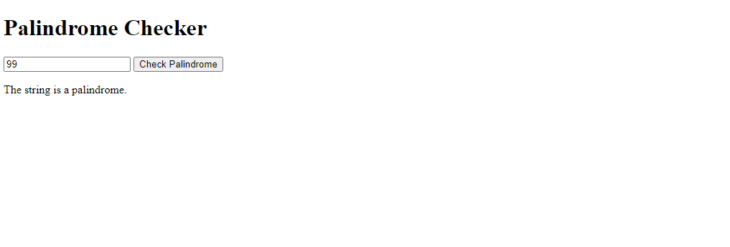

***Question No 5:***

* *Find the sum of all positive numbers in an array.*

***SYNTAX:***

<!DOCTYPE html>

<html lang="en">

<head>

    <meta charset="UTF-8">

    <meta name="viewport" content="width=device-width, initial-scale=1.0">

    <title>Positive Number Sum</title>

</head>

<body>

    <h1>Positive Number Sum</h1>

    <p>Enter numbers separated by commas:</p>

    <input type="text" id="inputNumbers" placeholder="e.g. 3, -2, 7, 0, -5, 9, -1, 4">

    <button onclick="calculateSum()">Calculate Sum</button>

    <p id="result"></p>

    <script>

*function* sumOfPositiveNumbers(*arr*) {

*let* sum = 0;

            for (*let* i = 0; i < *arr*.length; i++) {

                if (*arr*[i] > 0) {

                    sum += *arr*[i];

                }

            }

            return sum;

        }

*function* calculateSum() {

*const* inputNumbers = document.getElementById("inputNumbers").value;

*const* numbersArray = inputNumbers.split(",").map(*numStr* *=>* parseInt(*numStr*.trim()));

*const* positiveSum = sumOfPositiveNumbers(numbersArray);

*const* resultElement = document.getElementById("result");

            resultElement.textContent = `Sum of positive numbers: ${positiveSum}`;

        }

    </script>

</body>

</html>

***OUTPUT:***

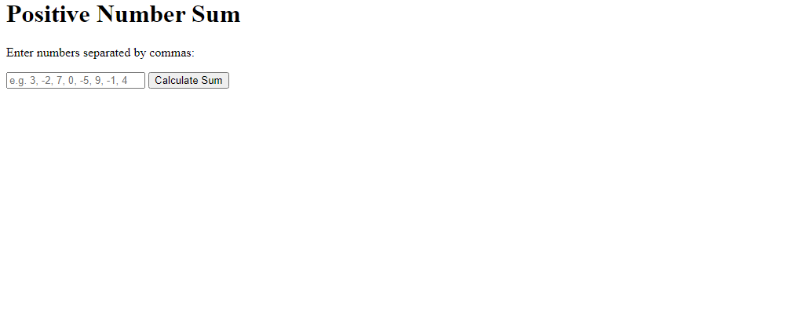

***RESULT:***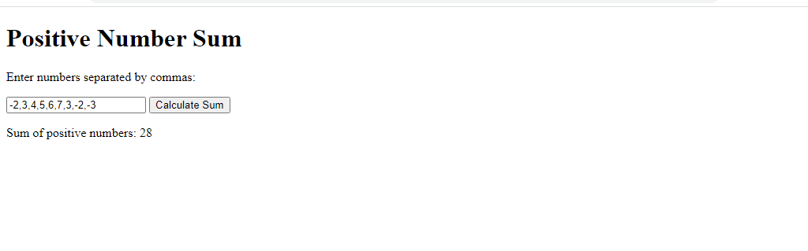

***Question No 6:***

* *Find the index of the first occurrence of a specific element in an array.*

***SYNTAX****:*

<!DOCTYPE html>

<html lang="en">

<head>

    <meta charset="UTF-8">

    <meta name="viewport" content="width=device-width, initial-scale=1.0">

    <title>Element Index Finder</title>

</head>

<body>

    <h1>Element Index Finder</h1>

    <p>Enter numbers separated by commas:</p>

    <input type="text" id="inputNumbers" placeholder="e.g. 3, 7, 2, 8, 5, 7">

    <p>Enter the target number:</p>

    <input type="text" id="targetNumber" placeholder="e.g. 7">

    <button onclick="findIndex()">Find Index</button>

    <p id="result"></p>

    <script>

*function* indexOfFirstOccurrence(*arr*, *target*) {

            for (*let* i = 0; i < *arr*.length; i++) {

                if (*arr*[i] === *target*) {

                    return i;

                }

            }

            return -1;

        }

*function* findIndex() {

*const* inputNumbers = document.getElementById("inputNumbers").value;

*const* numbersArray = inputNumbers.split(",").map(*numStr* *=>* parseInt(*numStr*.trim()));

*const* targetNumber = parseInt(document.getElementById("targetNumber").value);

*const* index = indexOfFirstOccurrence(numbersArray, targetNumber);

*const* resultElement = document.getElementById("result");

            if (index !== -1) {

                resultElement.textContent = `Index of first occurrence of ${targetNumber}: ${index}`;

            } else {

                resultElement.textContent = `${targetNumber} not found in the array.`;

            }

        }

    </script>

</body>

</html>

***OUTPUT:***

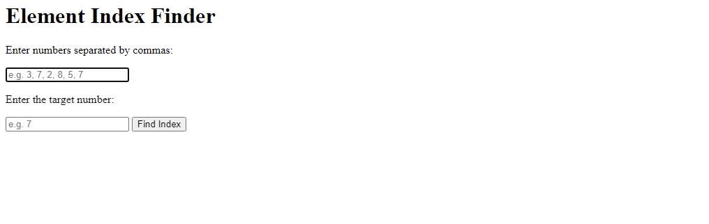

*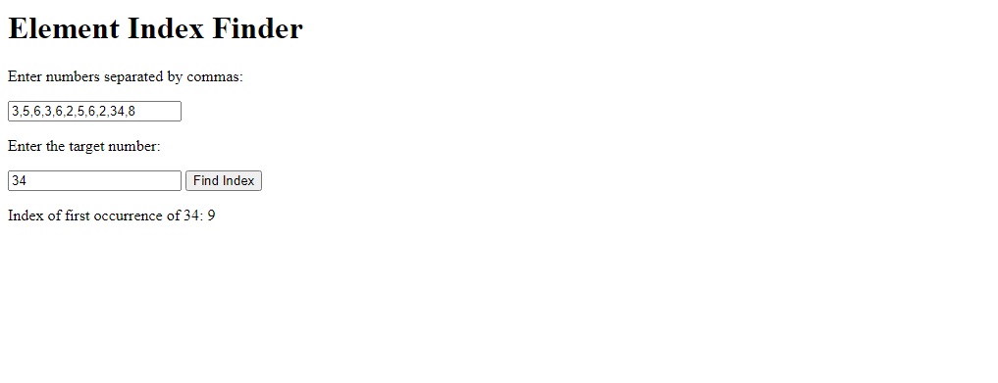****RESULT:***

***Question No 7:***

* *Remove all duplicates from an array without built-in methods.*

***SYNTAX:***

<!DOCTYPE html>

<html lang="en">

<head>

    <meta charset="UTF-8">

    <meta name="viewport" content="width=device-width, initial-scale=1.0">

    <title>Duplicate Removal</title>

</head>

<body>

    <h1>Duplicate Removal</h1>

    <p>Enter numbers separated by commas:</p>

    <input type="text" id="inputNumbers" placeholder="e.g. 3, 7, 2, 8, 5, 7, 2, 9, 3">

    <button onclick="removeDuplicates()">Remove Duplicates</button>

    <p id="result"></p>

    <script>

*function* removeDuplicates() {

*const* inputNumbers = document.getElementById("inputNumbers").value;

*const* originalArray = inputNumbers.split(",").map(*numStr* *=>* parseInt(*numStr*.trim()));

*const* uniqueArray = [];

            for (*let* i = 0; i < originalArray.length; i++) {

                if (uniqueArray.indexOf(originalArray[i]) === -1) {

                    uniqueArray.push(originalArray[i]);

                }

            }

*const* resultElement = document.getElementById("result");

            resultElement.textContent = "Array with duplicates removed: " + uniqueArray.join(", ");

        }

    </script>

</body>

</html>

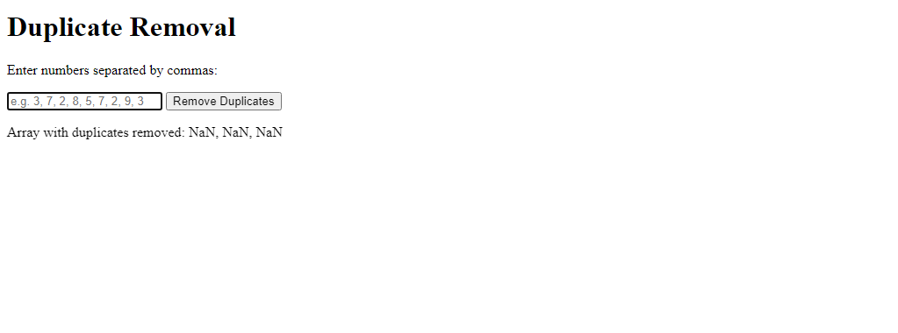***OUTPUT:***

***RESULT:***

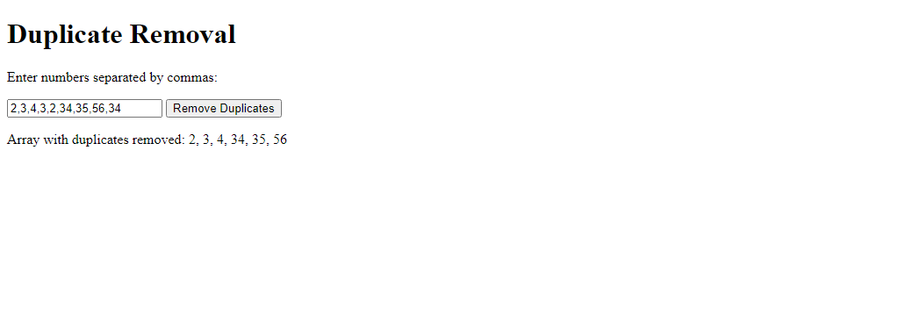

***Question No 8:***

* *Sort the array in ascending and descending without built-in methods.*

***SYNTAX:***

<!DOCTYPE html>

<html lang="en">

<head>

    <meta charset="UTF-8">

    <meta name="viewport" content="width=device-width, initial-scale=1.0">

    <title>Array Sorting</title>

</head>

<body>

    <h1>Array Sorting</h1>

    <p>Enter numbers separated by commas:</p>

    <input type="text" id="inputNumbers" placeholder="e.g. 3, 7, 2, 8, 5, 1, 9, 4">

    <button onclick="sortArrays()">Sort Arrays</button>

    <br>

    <p id="result"></p>

    <script>

*function* sortAscending(*arr*) {

            for (*let* i = 0; i < *arr*.length - 1; i++) {

                for (*let* j = i + 1; j < *arr*.length; j++) {

                    if (*arr*[i] > *arr*[j]) {

*const* temp = *arr*[i];

*arr*[i] = *arr*[j];

*arr*[j] = temp;

                    }

                }

            }

            return *arr*;

        }

*function* sortDescending(*arr*) {

            for (*let* i = 0; i < *arr*.length - 1; i++) {

                for (*let* j = i + 1; j < *arr*.length; j++) {

                    if (*arr*[i] < *arr*[j]) {

*const* temp = *arr*[i];

*arr*[i] = *arr*[j];

*arr*[j] = temp;

                    }

                }

            }

            return *arr*;

        }

*function* sortArrays() {

*const* inputNumbers = document.getElementById("inputNumbers").value;

*const* originalArray = inputNumbers.split(",").map(*numStr* *=>* parseInt(*numStr*.trim()));

*const* ascendingArray = sortAscending([...originalArray]);

*const* descendingArray = sortDescending([...originalArray]);

*const* resultElement = document.getElementById("result");

            resultElement.textContent = "Original Array: " + originalArray.join(", ") +

                                         "\nAscending Array: " + ascendingArray.join(", ") +

                                         "\nDescending Array: " + descendingArray.join(", ");

        }

    </script>

</body>

</html>

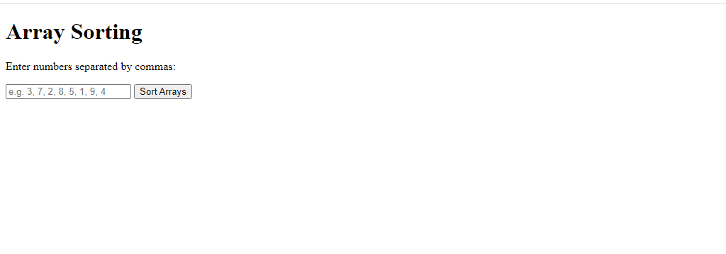***OUTPUT:***

***RESULT:***

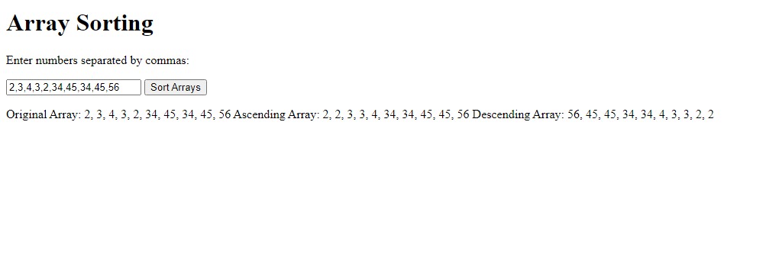

***Question No 9:***

* *Print all even numbers between 1 and 20 using a while loop.*

***SYNTAX:***

<!DOCTYPE html>

<html lang="en">

<head>

    <meta charset="UTF-8">

    <meta name="viewport" content="width=device-width, initial-scale=1.0">

    <title>Even Numbers</title>

</head>

<body>

    <h1>Even Numbers</h1>

    <p>Even numbers between 1 and 20:</p>

    <pre id="result"></pre>

    <script>

*function* printEvenNumbers() {

*let* number = 2;

*let* evenNumbers = "";

            while (number <= 20) {

                evenNumbers += number + "\n";

                number += 2;

            }

            document.getElementById("result").textContent = evenNumbers;

        }

        printEvenNumbers();

    </script>

</body>

</html>

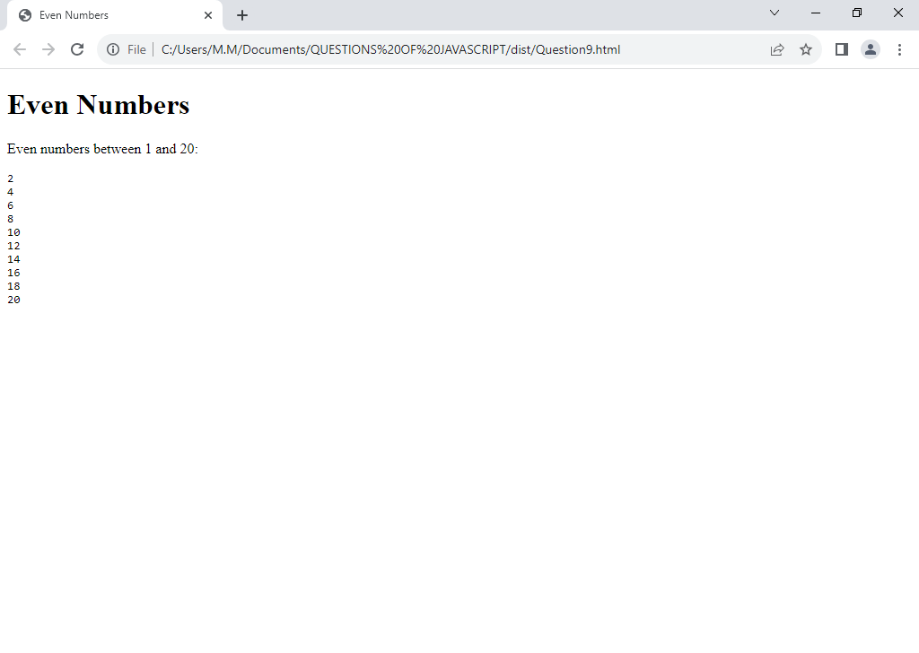***OUTPUT:***

***Question No 10:***

* *Calculate the factorial of a number using a do-while loop.*

***SYNTAX:***

<!DOCTYPE html>

<html lang="en">

<head>

    <meta charset="UTF-8">

    <meta name="viewport" content="width=device-width, initial-scale=1.0">

    <title>Factorial Calculator</title>

</head>

<body>

    <h1>Factorial Calculator</h1>

    <p>Enter a number:</p>

    <input type="number" id="inputNumber" placeholder="Enter a number">

    <button onclick="calculateFactorial()">Calculate Factorial</button>

    <p id="result"></p>

    <script>

*function* calculateFactorial() {

*const* inputNumber = parseInt(document.getElementById("inputNumber").value);

*let* factorial = 1;

*let* i = 1;

            do {

                factorial *= i;

                i++;

            } while (i <= inputNumber);

*const* resultElement = document.getElementById("result");

            resultElement.textContent = `Factorial of ${inputNumber} is ${factorial}`;

        }

    </script>

</body>

</html>

***OUTPUT:***

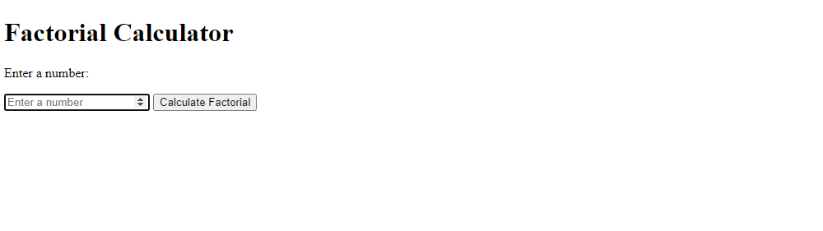

***RESULT:***

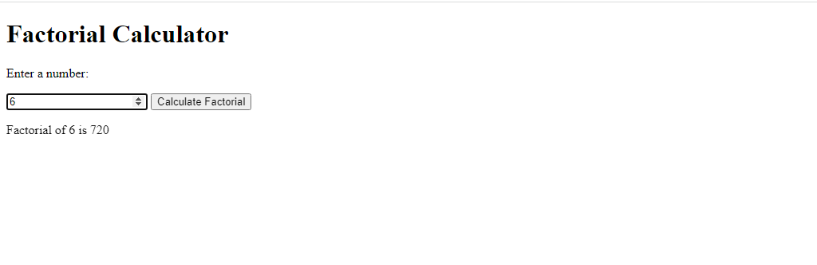

***Question No 11:***

* *Iterate through the properties of an object using a for-in loop.*

***SYNTAX:***

<!DOCTYPE html>

<html lang="en">

<head>

    <meta charset="UTF-8">

    <meta name="viewport" content="width=device-width, initial-scale=1.0">

    <title>Object Property Iteration</title>

</head>

<body>

    <h1>Object Property Iteration</h1>

    <pre id="result"></pre>

    <script>

*const* person = {

            firstName: "John",

            lastName: "Doe",

            age: 30,

            occupation: "Engineer"

        };

*let* output = "";

        for (*const* property in person) {

            if (person.hasOwnProperty(property)) {

                output += `${property}: ${person[property]}\n`;

            }

        }

        document.getElementById("result").textContent = output;

    </script>

</body>

</html>

***OUTPUT:***

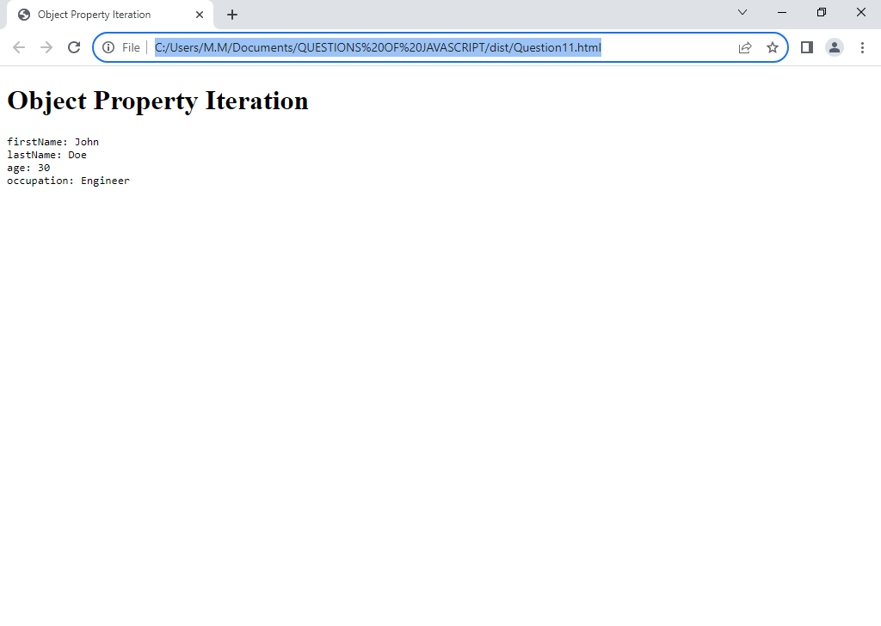

***Question No 12:***

* *Loop through an array using a for-of loop and double each element.*

***SYNTAX:***

<!DOCTYPE html>

<html lang="en">

<head>

    <meta charset="UTF-8">

    <meta name="viewport" content="width=device-width, initial-scale=1.0">

    <title>Array Doubling</title>

</head>

<body>

    <h1>Array Doubling</h1>

    <p>Original Array: <span id="originalArray"></span></p>

    <p>Doubled Array: <span id="doubledArray"></span></p>

    <script>

*const* originalArray = [2, 5, 8, 19, 15];

*const* doubledArray = [];

        for (*const* element of originalArray) {

            doubledArray.push(element * 2);

        }

        document.getElementById("originalArray").textContent = originalArray.join(", ");

        document.getElementById("doubledArray").textContent = doubledArray.join(", ");

    </script>

</body>

</html>

***OUTPUT:***



***Question No 13:***

* *Check if a number is even or odd and return a corresponding message.*

***SYNTAX:***

<!DOCTYPE html>

<html lang="en">

<head>

    <meta charset="UTF-8">

    <meta name="viewport" content="width=device-width, initial-scale=1.0">

    <title>Even-Odd Checker</title>

</head>

<body>

    <h1>Even-Odd Checker</h1>

    <p>Enter a number:</p>

    <input type="number" id="inputNumber" placeholder="Enter a number">

    <button onclick="checkEvenOrOdd()">Check</button>

    <p id="result"></p>

    <script>

*function* checkEvenOrOdd() {

*const* inputNumber = parseInt(document.getElementById("inputNumber").value);

*let* message;

            if (inputNumber % 2 === 0) {

                message = `${inputNumber} is even.`;

            } else {

                message = `${inputNumber} is odd.`;

            }

            document.getElementById("result").textContent = message;

        }

    </script>

</body>

</html>

***OUTPUT:***

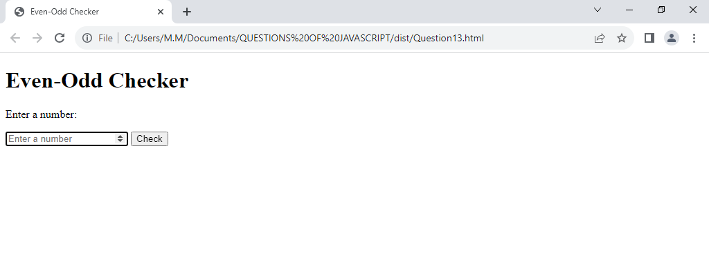

***RESULT:***

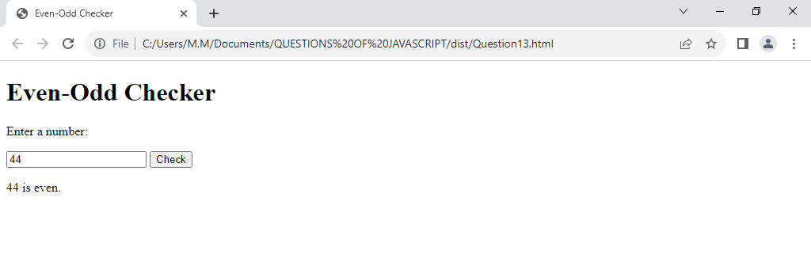

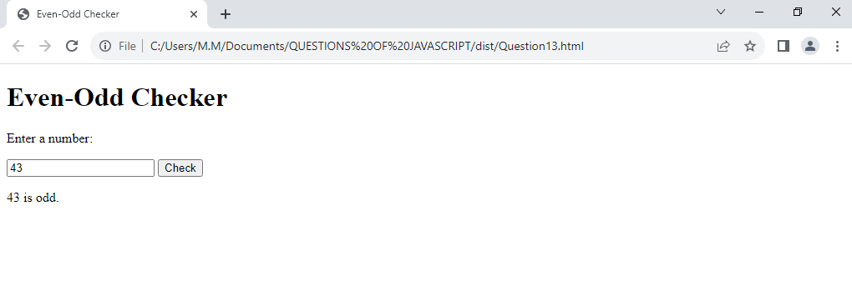

***Question No 14:***

* *Find the maximum of three numbers using nested ternary operators*

***SYNTAX:***

<!DOCTYPE html>

<html lang="en">

<head>

    <meta charset="UTF-8">

    <meta name="viewport" content="width=device-width, initial-scale=1.0">

    <title>Maximum of Three Numbers</title>

</head>

<body>

    <h1>Maximum of Three Numbers</h1>

    <p>Enter three numbers:</p>

    <input type="number" id="num1" placeholder="Enter the first number">

    <input type="number" id="num2" placeholder="Enter the second number">

    <input type="number" id="num3" placeholder="Enter the third number">

    <button onclick="findMaxAndDisplay()">Find Maximum</button>

    <p id="result"></p>

    <script>

*function* findMaxOfThreeNumbers(*a*, *b*, *c*) {

            return *a* > *b* ? (*a* > *c* ? *a* : *c*) : (*b* > *c* ? *b* : *c*);

        }

*function* findMaxAndDisplay() {

*const* num1 = parseInt(document.getElementById("num1").value);

*const* num2 = parseInt(document.getElementById("num2").value);

*const* num3 = parseInt(document.getElementById("num3").value);

*const* maxNumber = findMaxOfThreeNumbers(num1, num2, num3);

*const* resultElement = document.getElementById("result");

            resultElement.textContent = `The maximum of ${num1}, ${num2}, and ${num3} is ${maxNumber}`;

        }

    </script>

</body>

</html>

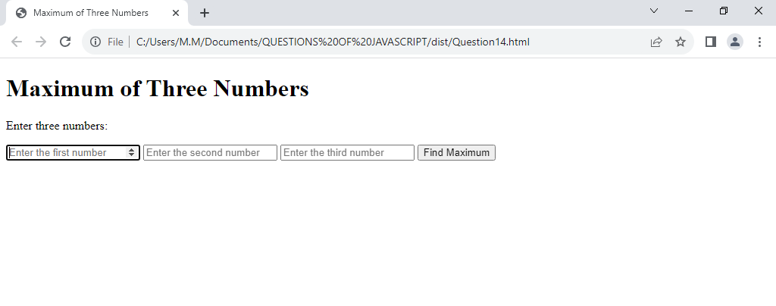***OUTPUT:***

***RESULT:***

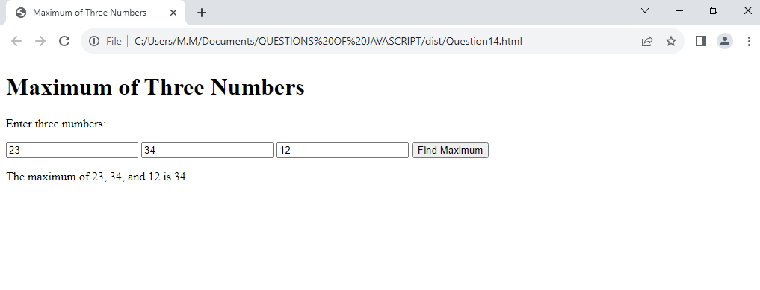

***Question No 15:***

* *Determine if a year is a leap year or not.*

***SYNTAX:***

<!DOCTYPE html>

<html lang="en">

<head>

    <meta charset="UTF-8">

    <meta http-equiv="X-UA-Compatible" content="IE=edge">

    <meta name="viewport" content="width=device-width, initial-scale=1.0">

    <title>JavaScript</title>

</head>

<body>

    <script>

*var* leapyear = prompt("Enter Your BirthYear");

        (leapyear%4==0)?

        document.write("Leap Year"):

        document.write("Not Leap Year");

    </script>

</body>

</html>

***OUTPUT:***

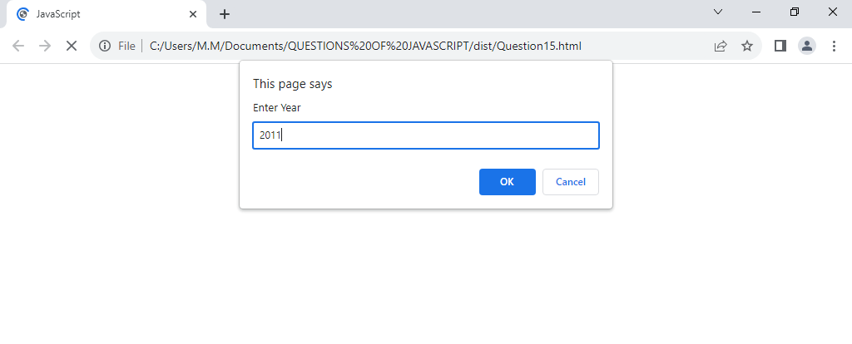

***RESULT:***

